**IT24102618**

**Manawadu U.J**

**IT2120 - Probability and Statistics – Lab Sheet 07**

**Exercise**





1)

2)

3)

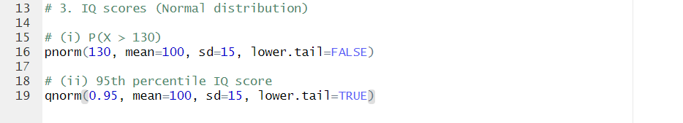3)

